

FACULTY OF ENGINEERING & TECHNOLOGY

ASSIGNMENT 2 REPORT OF COMPUTER PROGRAMMNIG USING MATLAB

PRESENTED TO
THE COMPUTER PROGRAMMING COURSE LECTURER
MR. MASERUKA BENDICTO

By GROUP 8 BEM

GROUP MEMBERS
NAMES | REG NUMBER | PROGRAM
ENYUKU PIUS | BU/UP/2025/4638 | BEM
MUGUSHA JOB | BU/UP/2025/05719 | BEM
RUBANGAKENE JONATHAN | BU/UP/2025/1994 | BEM
KISOLO OWEN SAM | BU/UP/2025/05873 | BEM
HAFIZAH KHADIJAH MUSA | BU/UP/2025/4608 | BEM

ABSTRACT
This report details a two-part MATLAB assignment focused on applying data handling and organization skills building from assignment one as we studied from module one to four during lecture time.
From question one of assignment one, we were to use that data to visualize the parameters, patterns trends and relationships saving the plot as an image and labelling it.
Also from question two of assignment one, we were to describe the different statistical characteristics in data and ensure they are visualized and the different attributes per individual are detailed enough to describe them.

ACKNOWLEGEMENT
We thank God Almighty for the gift of life, love and wisdom throughout this course.
Also our gratitude goes to our course lecturer, Mr. Maseruka Bendicto for guiding us in this course that is a necessity in our engineering professions.
And lastly, appreciation goes to all our group members for the commitment and team spirit which simplified work and made it easy for us to complete the task and come up with this report.

DECLARATION
We, Group 8 members hereby declare that report is to the best of our knowledge and has been developed and written by us. It includes the details of the assignment and it has never been presented by any individual.
Group 8

NAMES | REG NUMBER | PROGRAM
ENYUKU PIUS | BU/UP/2025/4638 | BEM
MUGUSHA JOB | BU/UP/2025/05719 | BEM
RUBANGAKENE JONATHAN | BU/UP/2025/1994 | BEM
KISOLO OWEN SAM | BU/UP/2025/05873 | BEM
HAFIZAH KHADIJAH MUSA | BU/UP/2025/4608 | BEM

APPROVAL
This is to confirm that this report has been written and presented by Group 8, giving details of the assignment carried out.
Name ..............................................................................................................
Date ..................................................................................................................
Signature ........................................................................................................

TABLE OF CONENT

ABSTRACT ii
ACKNOWLEGEMENT iii
DECLARATION iv
APPROVAL v
Chapter 1: 6
Introduction 6
Chapter 2: SOLUTIONS 6
From question one 1: 6
Using the Dataset 6
Methodology 6
Chapter 3: 10
Conclusion and Learning Experience 10
Chapter 4: 11
References and Resources 11

Chapter 1:

Introduction
This report gives a detailed overview of the MATLAB assignment built from the two questions of assignment one showing use of the different MATLAB features from module one to module three. The first exercise focused on data input and output , specifically the process of inputing a dataset , structuring it for analysis, and exporting it to an organized Excel workbook. The second exercise involved a more focused task of writing a computer program that can calculate data . we were required to demonstrate fundamental skills in data handling, organization, MATLAB.
From question 1;
- Utilize all the knowledge obtained from module one to three to visualize the different parameters, patterns, trends and relationships.
- Ensure that each plot is saved as an image its well labelled.
From question 2;
Using the above information calculate the CPA and GPA

Chapter 2: SOLUTIONS

From question one 1:

Using the Dataset
The primary objective of this exercise was to create a MATLAB script suitable for handling an external dataset. Our approach was a three-step process:

Methodology
Data Acquisition and processing
Using the already cleaned dataset; Indian-Water data that we had used in the first assignment that was obtained from data inform of excel workbook.
Our task was to come up with a MATLAB code that would return different skills as required.
Below is a list of the different skills we were able to apply in question one
- Data input
- Importing data
- Data output
- plotting
Below is a code that returns all the above skills.
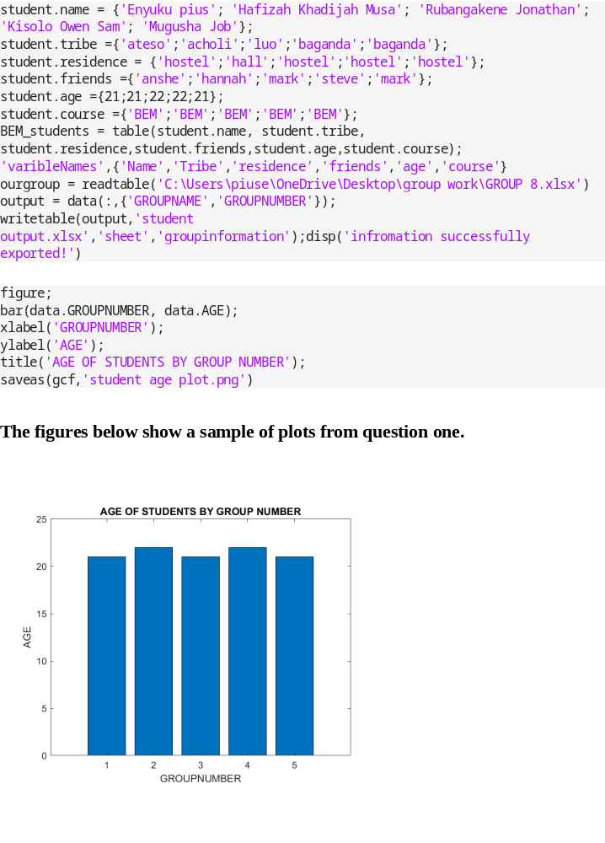

From question 2
Using the member attribute data.
This exercise required us to use the above information to calacute the GPA and CPA
Below are the matlab codes used
n = input('enter number of students:');
sem = input('enter number of semesters:');
coures = input('enter number of courses:');
for i = 1:n
fprintf('\nstudent%d\n',i);
totalpoints = 0;
totalcredits = 0;
for s = 1:sem
fprintf('\nstudent%d\n',s);
semesterpoints=0;
semestercredits=0;
for c =1:coures
mark = input(sprintf('enter mark for course %d;',c));
credit = input(sprintf('enter credit unit for course %d;', c));
if mark >= 80
gp=5;
elseif mark >= 75
gp=4.5;
elseif mark >= 70
gp=4;
elseif mark >= 65
gp=3.5;
elseif mark >= 60
gp=3;
elseif mark >= 55
gp=2.5;
elseif mark >= 50
gp = 2;
elseif mark >= 45
gp=1.5;
elseif mark >= 40
gp = 1;
else
gp=0;
end
semesterpoints = semesterpoints + (gp * credit);
semestercredits = semestercredits + gp;
end
GPA = semesterpoints / semestercredits;
fprintf('GPA for semester %d = %.2f\n',s,GPA);
totalpoints = totalpoints + semesterpoints;
totalcredits =totalcredits + semestercredits
end
CGA = totalpoints/totalcredits;
fprintf('\nstudent %d CGA = %.2f\n',i,CGA);
end

Chapter 3:

Conclusion and Learning Experience

This assignment has helped us to acquire knowledge and experience that helped us understand MATLAB programming concepts and gave us experience with the foundations we had acquired from Modules one to four. We also understood how to handle real-world data given we used the Kaggle dataset.
Generally, this assignment provided a practical foundation in data management and problem-solving within a computing environment.

Chapter 4:

References and Resources

- personal information source for the dataset used in question one.
- MATLAB Documentation - Used for syntax and function guidance on readtable(), struct(), and writetable().
- Microsoft Excel Cleaning techniques from Microsoft community forums.
- Computer programming lecture notes.

